Lecture 2.1.2
Partial Fraction

Course outcome to be covered:
CO1: Apply and recognized about the Partial Fraction

Partial Fraction
Partial Fractions are used to decompose a complex rational expression into two or more simpler fractions. Generally, fractions with algebraic expressions are difficult to solve and hence the concepts of partial fractions are used to split the fractions into numerous subfractions. While decomposition, generally, the denominator is an algebraic expression, and this expression is factorized to facilitate the process of generating partial fractions. A partial fraction is a reverse of the process of the addition of rational expressions.
When a rational expression is split into the sum of two or more rational expressions, the rational expressions that are a part of the sum are called partial fractions. This is referred to as splitting the given algebraic fraction into partial fractions. The denominator of the given algebraic expression has to be factorized to obtain the set of partial fractions.
Consider an algebraic fraction, (3x+5)/(2x2-5x-3).
This expression can be split into simple form like [2/(x – 3)] – [1/(2x + 1)].
The simpler parts [2/(x – 3)] and [1/(2x + 1)] are known as partial fractions.
This means that the algebraic expression can be written in the form, as given in the figure:
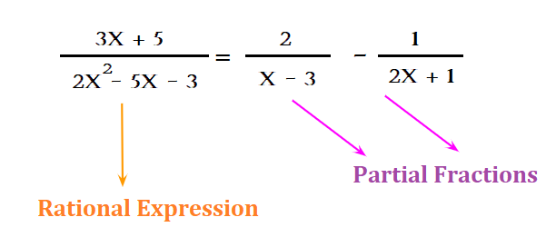
The partial fraction decomposition only works for the proper rational expression (the degree of the numerator is less than the degree of the denominator). In case, if the rational expression is an improper rational expression (the degree of the numerator is greater than the degree of the denominator), first do the division operation to convert it into proper rational expression. This can be achieved with the help of a polynomial long division method.
Partial Fraction Formulas:
The numerator of a partial fraction is not always a constant. If the denominator is a linear function, the numerator is constant. And, if the denominator is a quadratic equation, then the numerator is linear. It means, the numerator's degree of a partial fraction is always one less than the denominator's degree. Further, the rational expression needs to be a proper fraction to be decomposed into a partial fraction. Listed below in the table are partial fraction formulas (here, all variables apart from x are constants).

Form of Rational Fraction | Partial Fraction Decomposition
(px + q)/(ax + b) | A/(ax + b)
(px + q)/(ax + b)^{n} | A₁/(ax + b) + A₂/(ax + b)² + .......... A_{n}/(ax + b)^{n}
(px² + qx + r)/(ax² + bx + c) | (Ax + B)/(ax² + bx + c)
(px² + qx + r)/(ax² + bx + c)^{n} | (A₁x + B₁)/(ax² + bx + c) + (A₂x + B₂)/(ax² + bx + c)² + ...(A_{n}x + B_{n})/(ax² + bx + c)^{n}

Examples:
· 4/[(x - 1)(x + 5)] = [A/(x - 1)] + [B/(x + 5)]
· (3x + 1)/[(2x - 1)(x + 2)²] = [A/(2x - 1)] + [B/(x + 2)] + [C/(x + 2)²]
· (2x - 3)/[(x - 2)(x² + 1)] = [A/(x - 2)] + [(Bx + C)/(x² + 1)]
In all these examples, A, B, and C are constants to be determined.
Partial Fraction Decomposition
The partial fraction decomposition is writing a rational expression as the sum of two or more partial fractions. The following steps are helpful to understand the process of decomposition of partial fractions.
Step-1: Factorize the numerator and denominator and simplify the rational expression, before doing partial fraction decomposition.
Step-2: Split the rational expression as per the formula for partial fractions. P/((ax + b)² = [A/(ax + b)] + [B/(ax + b)²]. There are different partial fractions formulas based on the numerator and denominator expression.
Step-3: Take the LCM of the factors of the denominators of the partial fractions, and multiply both sides of the equation with this LCM.
Step-4: Simplify and obtain the values of A and B by comparing coefficients of like terms on both sides.
Step-5: Substitute the values of the constants A and B on the right side of the equation to obtain the partial fraction.
Example:
Find the partial fraction expansion of the expression (4x + 12)/(x² + 4x).
Always remember to factor the denominator as much as possible before doing the partial fraction decomposition.
(4x + 12)/(x2 + 4x) = (4x + 12)/[x(x + 4)] ;
The denominator has non-repeated linear factors. So, every factor corresponds to a constant in the numerator while writing the partial fractions.
Let, (4x + 12)/[(x)(x + 4)] = [A/x] + [B/(x + 4)] → (1)
The LCD (Least Common Denominator) of the sum (on the right side) is x(x + 4). Multiplying both sides by x(x + 4), 4x + 12 = A(x + 4) + Bx → (2)
To solve it for A and B, set each linear factor to zero.
Substitute x + 4 = 0 , or x = -4 in (2):
4(-4) + 12 = A(0) + B(-4); -4 = -4B;
B = 1.
Substitute x = 0 in (2):
4(0) + 12 = A(0 + 4) + B(0);
12 = 4A;
A = 3.
Substitute the values of A and B in (1), we get the partial fractions decomposition of the given expression: (4x + 12)/[x(x + 4)] = [3/x] + [1/(x + 4)]
Partial Fractions of Improper Fraction
To decompose an improper fraction into partial fractions, one should do the long division. The long division is helpful to give a whole number and a proper fraction. The whole number is the quotient in the long division, and the remainder forms the numerator of the proper fraction, and the denominator is the divisor. The format of the result of the long division would be Quotient + Remainder/Divisor. Let us understand more of this with the help of the below example.
Example:
Find the partial fraction decomposition of the expression (x3 +4x2 - 2x - 5)/(x2 - 4x + 4)
Solution: Here, the degree of the numerator (3) is greater than the degree of the denominator (2).
So, the given fraction is improper, long division method is used.
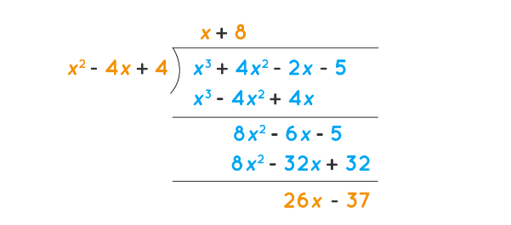
Then write the given fraction as Quotient+ Remainder/Divisor.
(x³ + 4x² - 2x - 5)/(x² - 4x + 4) = x + 8 + (26x - 37)/(x²- 4x + 4).
Here, the fraction on the right side is a proper fraction and hence it can be split into partial fractions.
(26x - 37)/(x² - 4x + 4) = (26x - 37)/(x - 2)² = A/(x - 2)+ B/(x - 2)²
To solve for A and B. Set each of (x - 2) and x one by one to zero to get A and B. You should get A = 26 and B = 15.
Substituting these values in we have: (26x-37)/(x² - 4x + 4) = [26/(x-2)] + [15/(x-2)²]
Further we have: (x³+ 4x² - 2x - 5)/(x²- 4x + 4) = x + 8 + [26/(x - 2)] + [15/(x - 2)² ]
Partial Fraction Decomposition
The following points would help in gaining a clearer understanding of partial fractions.
- The numerator's degree of a partial fraction is always just 1 less than the denominator's degree.
- When a partial fraction has repeated factors of the form:
- (ax + b)^{n} or (ax² + b² + c)^{n}, they correspond to n different partial fractions where the denominators of the partial fractions have exponents 1, 2, 3, ..., n.
- The above partial fractions formulas do not depend upon the numerator of the given rational expression.
- Before applying the above formulas, factorize the denominator as much as possible. Otherwise, the answer won't be accurate
Partial Fractions
The following points are helpful to decompose a fraction into its partial fractions.
- If the denominator has non-repeated linear factors:
- The constants can be obtained by setting each linear factor to zero.
- If the denominator has either repeated linear factors and/or irreducible quadratic factors:
- Set the linear factors to zero to find the value of some constants.
- Set x = 0 to get at least one another constant.
- Compare the coefficients of x3, x2, ..., etc to find the other constants.

Example:
Find the partial fraction decomposition of (x + 2) / [ (x + 1) (x - 2)].
Since the denominator has non-repeating linear factors, by the partial fraction formulas, assume that:
(x + 2) / [ (x + 1) (x - 2) ] = A / (x + 1) + B / (x - 2) ... (1)
Multiply both sides by (x + 1) (x - 2),
(x + 2) = A (x - 2) + B (x + 1)
Substitute x = -1: 1 = A (-3) ⇒ A = -1/3
Substitute x = 2: 4 = B (3) ⇒ B = 4/3
Substituting A and B values in (1):
(x + 2) / [ (x + 1) (x - 2) ] = -1 / [3(x + 1)] + 4 / [3(x - 2)]
Answer: -1 / [3(x + 1)] + 4 / [3(x - 2)]

eBook Discrete Mathematics:
https://www.pbte.edu.pk/text%20books/dae/math_113/Chapter_04.pdf

video link:
https://www.youtube.com/watch?v=QKkdYW77xNI

